How to Use

**Google Meet**

**► To Set Up a Meeting**

1. Login in to your Google account (Gmail).
2. Click on the Google Apps waffle.
3. Click on the Google Meet icon.

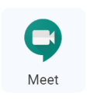

1. Click Join or Start a Meeting.

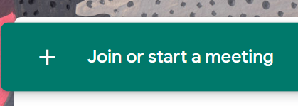

1. Give your meeting a Nickname. Click Continue.

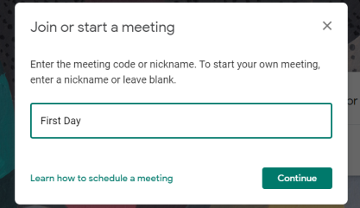

1. Click Join Now.

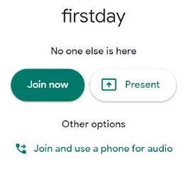

1. Here you can (1) copy joining info to post in Google Classroom and (2) add students and administrators to your meeting.

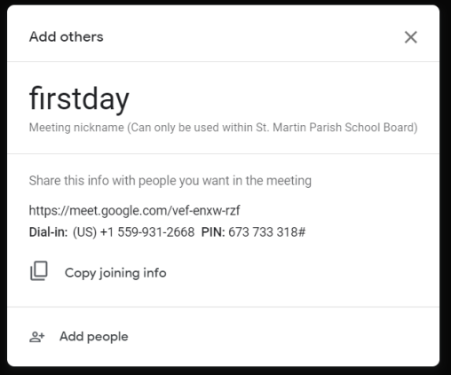

(2)

(1)

**► To Manage a Meeting**

1. Click on the (1) three-dot column at the bottom right of the screen to use the options available. Once the open, use (2) Settings to control your audio and video and (3) Record to begin recording your presentation to use later in Google Classroom. Use (4) Present Now to share your screen, a different window, or another tab. Turn your microphone and camera on/off or leave a meeting with the (5) round buttons at the bottom of the screen.

(3))

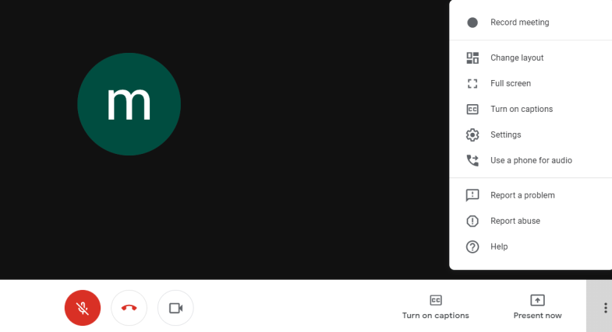

(1)

(2)

(5)

(4))

1. Use the People icon in the top-right corner to access a list of participants in your meeting.



1. From here you can Mute or Remove a student.

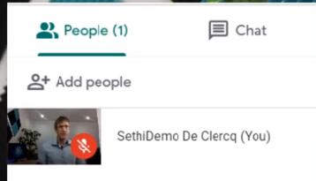

**► To View a Tutorial**

I suggest “How to use Google Meet for Remote and Online learning” by Flipped Classroom Tutorials, which is available on YouTube.